Step 1: Create Database
ANS :
CREATE DATABASE database_assignment;
USE database_assignment;



Step 2: Create Country Table
ANS :
CREATE TABLE country (
id INT PRIMARY KEY,
country_name VARCHAR(100),
country_name_eng VARCHAR(100),
country_code VARCHAR(10)
);

Step 3: Create City Table

ANS :
CREATE TABLE city (
id INT PRIMARY KEY,
city_name VARCHAR(100),
lat DECIMAL(10,6),
`long` DECIMAL(10,6),
country_id INT,
FOREIGN KEY (country_id) REFERENCES country(id)
);

Step 4: Create Customer Table
ANS : CREATE TABLE customer (
id INT PRIMARY KEY,
customer_name VARCHAR(100),
city_id INT,
customer_address VARCHAR(100),
next_call_date DATE,
ts_inserted DATETIME,
FOREIGN KEY (city_id) REFERENCES city(id)
);

Step 5: Insert Data into Country

ANS : INSERT INTO country VALUES
(1,'Deutschland','Germany','DEU'),
(2,'Srbija','Serbia','SRB'),
(3,'Hrvatska','Croatia','HRV'),
(4,'United States of America','United States of America','USA'),
(5,'Polska','Poland','POL'),
(6,'España','Spain','ESP'),
(7,'Rossiya','Russia','RUS');

Step 6: Insert Data into City
ANS : INSERT INTO city VALUES
(1,'Berlin',52.520008,13.404954,1),
(2,'Belgrade',44.787197,20.457273,2),
(3,'Zagreb',45.815399,15.966568,3),
(4,'New York',40.730610,-73.935242,4),
(5,'Los Angeles',34.052235,-118.243683,4),
(6,'Warsaw',52.237049,21.017532,5);

Step 7: Insert Data into Customer
ANS : INSERT INTO customer VALUES
(1,'Jewelry Store',4,'Long Street 120','2020-01-21','2020-01-09 14:01:20'),
(2,'Bakery',1,'Kurfürstendamm 25','2020-02-21','2020-01-09 17:52:15'),
(3,'Café',1,'Tauentzienstraße 44','2020-01-21','2020-01-10 08:02:49'),
(4,'Restaurant',3,'Ulica Ipa 15','2020-01-21','2020-01-10 09:20:21');

Step 10: Display Customer Table
ANS : Step 10: Display Customer Table
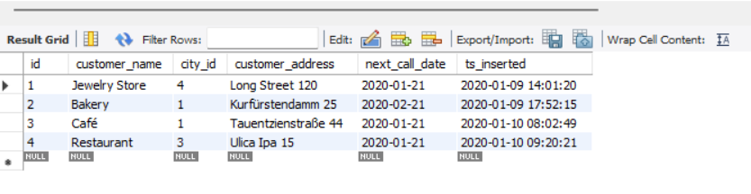

Task 1 : (join multiple tables using left join) List all Countries and customers related to these countries. For each country displaying its name in English, the name of the city customer is located in as well as the name of the customer. Return even countries without related cities and customers.

ANS : SELECT
c.country_name_eng AS Country,
ct.city_name AS City,
cu.customer_name AS Customer
FROM country c
LEFT JOIN city ct
ON c.id = ct.country_id
LEFT JOIN customer cu
ON ct.id = cu.city_id
ORDER BY c.country_name_eng;

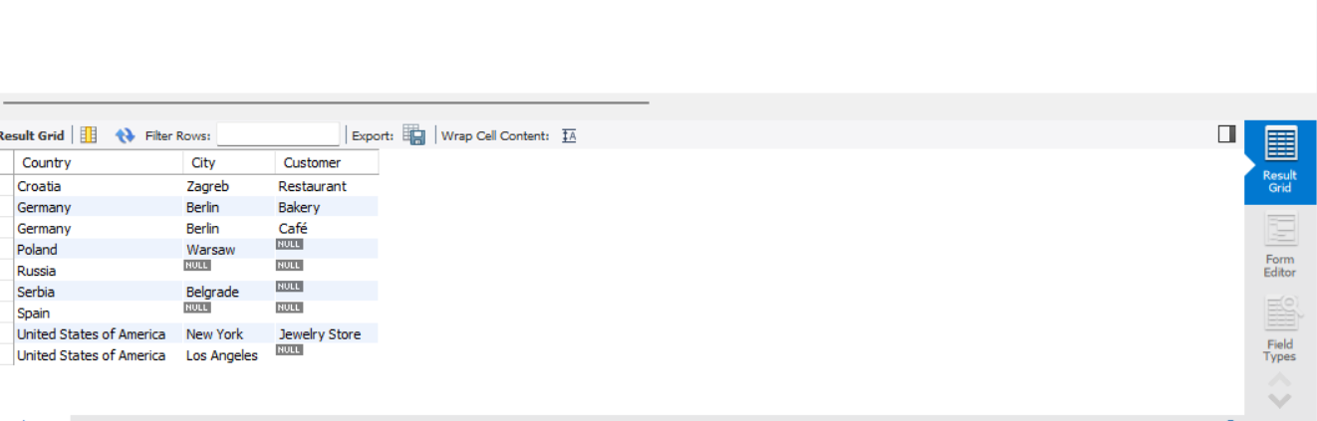

Task 2 : (join multiple tables using both left and inner join) Return the list of all countries that have pairs(exclude countries which are not referenced by any city). For such pairs return all customers. Return even pairs of not having a single customer

ANS : SELECT
c.country_name_eng AS Country,
ct.city_name AS City,
cu.customer_name AS Customer
FROM country c
INNER JOIN city ct
ON c.id = ct.country_id
LEFT JOIN customer cu
ON ct.id = cu.city_id
ORDER BY c.country_name_eng;

